**MTH 151 Ch 8 Writing Assignment**

**In Section 8.6, page 482, read problem # 62**. In THIS Word document, type out your answers in a clear and precise manner. Use Math Type (Ryan 416) , or some Math Editor found on your computer, to type your mathematical notation in a professional manner. Also use Shapes within Word (or some method) to create a diagram of the circle you are asked to work. I give you the picture of the tank below.

*(Graphic below is from the text book we are currently using: Calculus, 13/e, George Thomas Jr , Maurice Weir and Joel Hass)*

**Problem:** The head of your firm’s accounting department has asked you to find a formula she can use in a computer program to calculate the year-end inventory of gasoline in the company’s tank. A typical tank is shaped like a right circular cylinder of radius r and length L, mounted horizontally, as shown below. The data comes to the accounting office as depth measurements taken with a vertical measuring stick marked in centimeters.

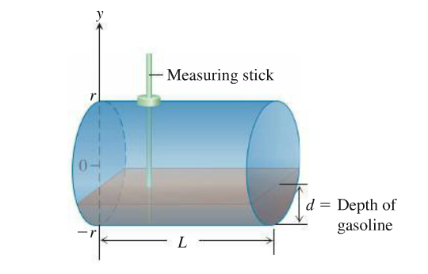

**Part a:** Show, in the notation of the figure, that the volume of gasoline that fills the tank to a depth *d* is .

We know that the equation of any circle is given by: $x^{2}+y^{2}=r^{2}$. When we solve for x, we find: x = $\sqrt{r^{2}-y^{2}}$. To find the Volume, we also know we must integrate the area, so let’s first find area. Area is given by the equation: $A= L×W$. So, $V=\int_{a}^{b}{L*Wdx}$. From the circle diagram, we see that W goes from -x to x, which is equivalent to 2x, so $W=2x$, where x $=\sqrt{r^{2}-y^{2}}$. So, Area is given by the equation: $A=2L*\sqrt{r^{2}-y^{2}}$. To find Volume, we integrate the Area from point a to point b, as shown by the equation: $V=\int_{a}^{b}{2L* \sqrt{r^{2}-y^{2}}}$. Finally, we must find the limits of integration. If we look at the circle diagram, we see that the radius is given by r. At the bottom of the circle, the height is equal to -r, because you are a full distance, r, below the center. This tells us that a from our limits of integration is equal to -r. To find b from our limits of integration, we must find the height that the liquid is at. Let height of the liquid be represented by d. To find any given height of liquid, we add d to -r, giving us -r+d, our b term. Thus, our volume equation, is fully given to us with:



$V=\int_{-r}^{-r+d}{2L* \sqrt{r^{2}-y^{2}}}$.



**Part b:** Evaluate the integral.

Next, we will evaluate the integral: $V=\int_{-r+d}^{r}{2L* \sqrt{r^{2}-y^{2}dy}}$.

$V=\int_{-r+d}^{r}{2L* \sqrt{r^{2}-y^{2}dy}}$.

From the integral tables in the back of our Calculus textbook, we know that

$\int{\sqrt{a^{2}-x^{2}dx}}$ = $\frac{x}{2}\sqrt{a^{2}-x^{2}}+ \frac{a^{2}}{2}\sin^{-1}{\frac{x}{a}}+c$, so we use this equation to solve and get:

$V=2L×[ \frac{y}{2}\sqrt{r^{2}-y^{2}}+ \frac{r^{2}}{2}\sin^{-1}{(\frac{y}{r}) ]}{}_{-r}^{-r+d}{}$. The 2 from the 2L term can be distributed to further simplify, giving us: $V=L×[ y\sqrt{r^{2}-y^{2}}+ r^{2}\sin^{-1}{(\frac{y}{r}) ]}{}_{-r}^{-r+d}{}$. We then apply the limits and get: $V=L[ (-r+d)\sqrt{r^{2}-{(-r+d)}^{2}}+ r^{2}\sin^{-1}{(\frac{\left(-r+d\right)}{r}) ]-L[-r\sqrt{r^{2}-{\left(-r\right)}^{2}}+ r^{2}\sin^{-1}\left(\frac{-r}{r}\right)]}$. Now, we will simply this by combining like terms and reducing fractions:

$$V=L[ (-r+d)\sqrt{r^{2}-{(r^{2}-2rd+d^{2})}^{}}+ r^{2}\sin^{-1}{(\frac{\left(-r+d\right)}{r}) ]-L[-r\sqrt{r^{2}-r^{2}}+ r^{2}\sin^{-1}\left(-1\right)]}$$

Still simplifying: $$V=L[ (-r+d)\sqrt{{2rd-d^{2}}^{}}+ r^{2}\sin^{-1}{(\frac{-r}{r}+ \frac{d}{r}) ]-L[-r\sqrt{0}+ r^{2}\sin^{-1}\left(-1\right)]}$$

We will reduce more [note: that $\sin^{-1}{(-1)}= \frac{-π}{2}$] :

$$V=L[ (-r+d)\sqrt{{2rd-d^{2}}^{}}+ r^{2}\sin^{-1}{(\frac{d}{r}-1) ]-L[ r^{2}*} \frac{-π}{2}]$$

This can finally be simplified into: $$V=L[ (-r+d)\sqrt{{2rd-d^{2}}^{}}+ r^{2}\sin^{-1}{(\frac{d}{r}-1) ]-L(} \frac{-r^{2}π}{2})$$